
HOURLY TIME MANAGEMENT TEMPLATE

HOURLY TASK PLANNER

Use this hourly planner to layout tasks for yourself during the day. You can use this planner as a brainstorming guide or template for your schedule or calendar.

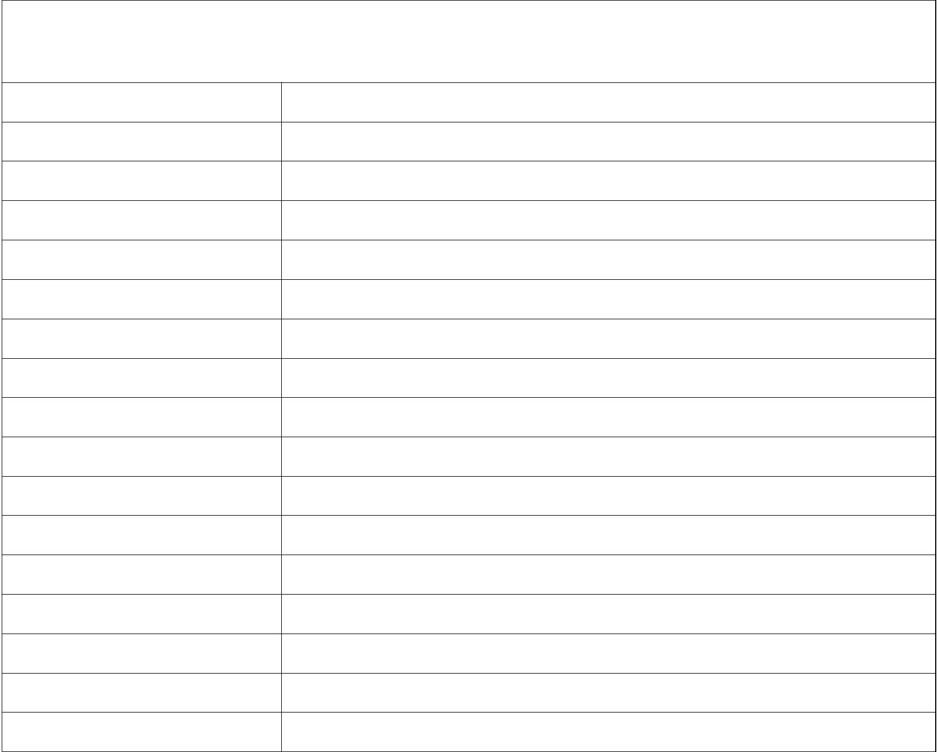
TIME OF DAY TASK

