Your 14-Day Log for Temperature and Symptoms

Write your symptoms and temperature in the space below every day for 14 days.
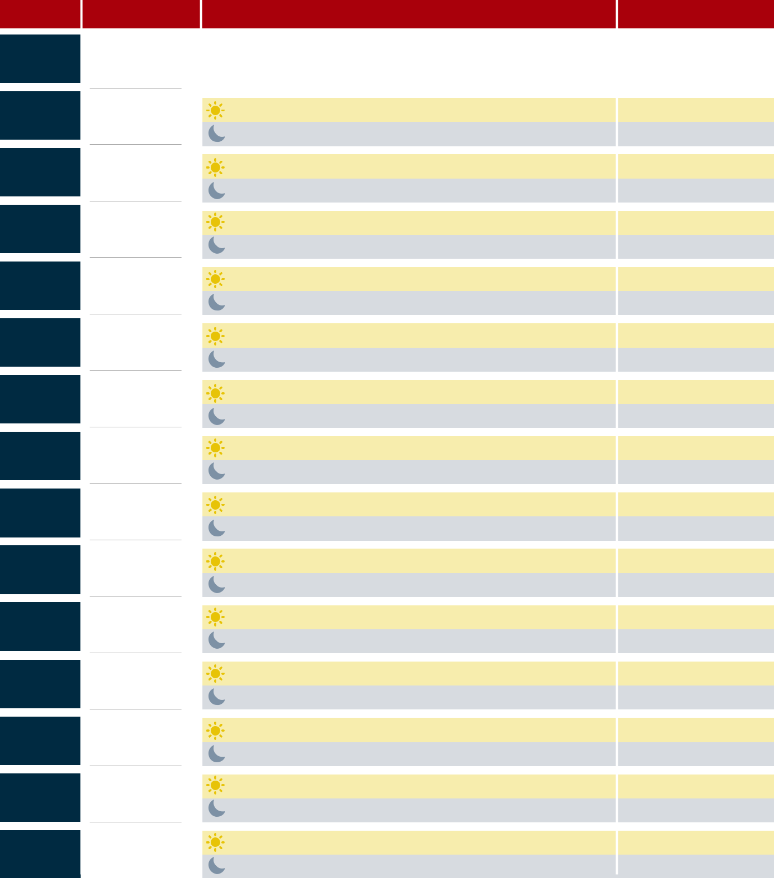

DAY

DAY 0

DAY 1

DAY 2

DAY 3

DAY 4

DAY 5

DAY 6

DAY 7

DAY 8

DAY 9

DAY 10

DAY 11

DAY 12

DAY 13

DAY 14


DATE

SYMPTOMS | TEMP

Day 0 is the day you left another country or returned home from a cruise.

If you get sick: • Stay home. Avoid contact with others. • You might have COVID-19;
Most people are able to recover at home without medical care. • If you have trouble
Breathing or are worried about your symptoms, call or text a health care provider.
Tell them about your recent travel and your symptoms. • Call ahead before you go to
a doctor’s office or emergency room.

