Daily Temperature Reading Log Template

Take your temperature around the same time each day for 14 days. Record temperature on the chart below.

Name: ___________________________________________________________________________
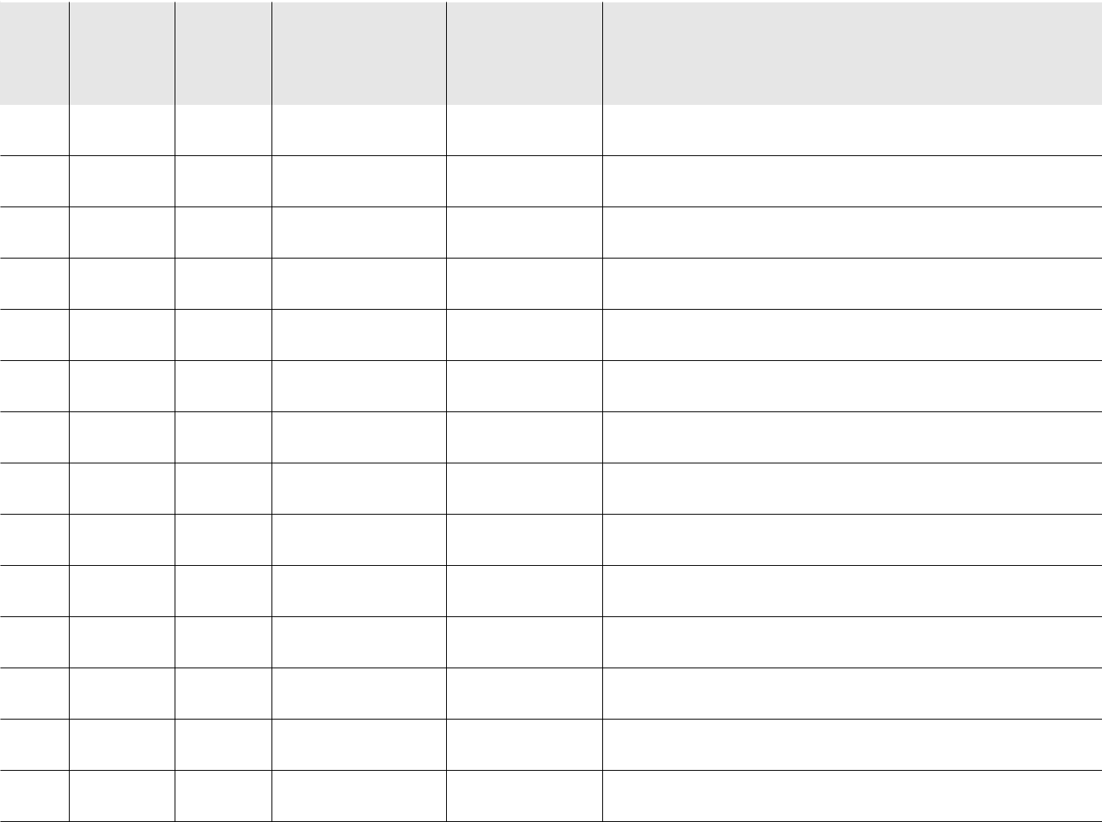

Day |  |  |  | Symptoms | If Yes to Symptoms, indicate what you
Day | Date | Time | Temperature | Symptoms | are feeling (example: cough, runny nose,
# | Date | Time | Temperature | (Yes or No) | are feeling (example: cough, runny nose,
# |  |  |  | (Yes or No) | shortness of breath)

1

2

3

4

5

6

7

8

9

10

11

12

13

14

Contact Peel Public Health at 905-799-7700 if your temperature reading is above 37.8°C or 100.0˚F.

