Sprint Planning Report Format

Team Name: ____________________ Sprint#: ___
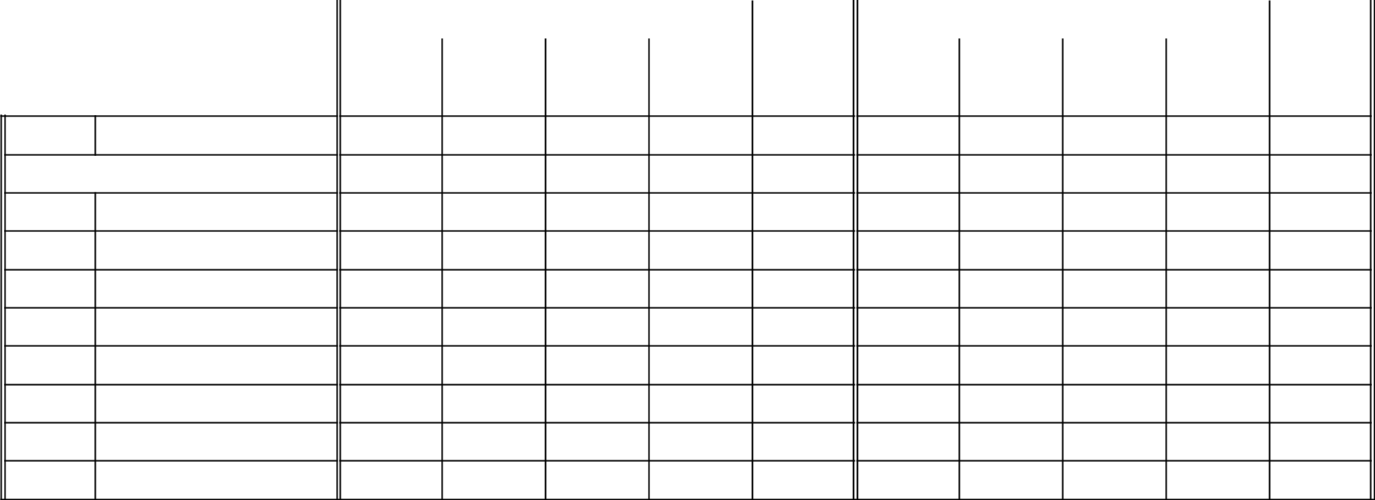

Sprint #___

Date Range

Team Member Team:

 |  | Initial Plan |  |  |  |  |  | Executed
 | Ind | Total | Group | Total | Total |  | Ind | Total | Group | Total | Total
 | Tasks | Time | Tasks | Time | Hours |  | Tasks | Time | Tasks | Time | Hours

Total:

Total:

Scrum Master: ____________________________

Sprint Planning Checklist:

___ Stories Well Defined ready for Customer Review (documented in repository)

___ Initial Tasks counts tallied (here) with hours & ownership

___ Each Team member has sufficient number of Tasks & Hours

___ Test Cases documented (in repository with Stories) ready for Customer Review (by early 2nd week)

___ Completed Tasks are marked with name and actual hours

___ Additional Tasks in Backlog

