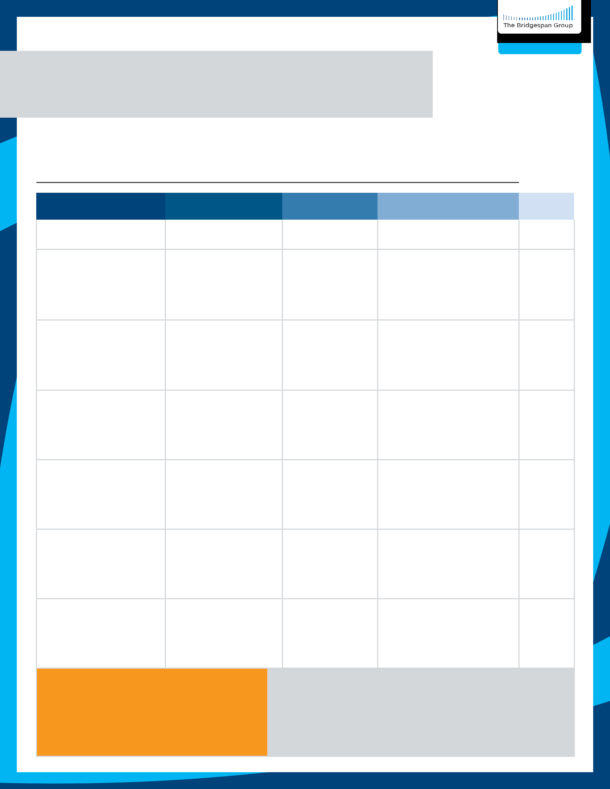
Effective

Meetings

Executive Team Meeting Agenda Template

Use this template to build an agenda for your next executive team meeting. The steps on the next page can help you hold effective meetings using this template as a guide.

Date: Meeting type:

TOPIC

Frame as a question

PURPOSE

E.g., decision, discussion, learning

LEADER

Name of topic owner who will facilitate discussion

PREPARATION

Pre-reads or other preparation expected of participants

TIME

Duration

Wrap up:

What decisions did we make today?

What actions do we need to take? Who is

responsible? By when?

What do we need to communicate? To

whom? By when?

19

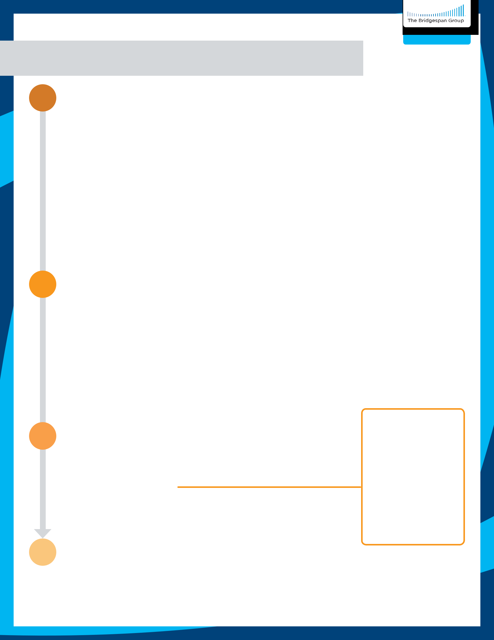
Effective

Meetings

Agenda Template: Instructions

1

2

3

Prepare for the meeting

- Identify agenda items

– Seek input from the team, but the CEO finalizes agenda, focusing on items aligned with the work of the team (e.g., high stakes/interdependence)

– Cancel the meeting if there are no critical agenda items

- Develop a written agenda

– Pose each agenda item as a question to make clear the purpose of the discussion (i.e., are you deciding, providing input, learning, or aligning on messaging?)

– For each topic, clarify who will lead it, what preparation is needed, and how long the discussion will be

– Assign meeting management roles (e.g., facilitator, recorder, timekeeper)

- Share agenda and materials in advance

– Set a norm for how far in advance the agenda will be sent out

– Clarify what preparation is expected and hold members accountable for doing it

Lead the meeting

- Begin meeting by reviewing agenda and roles

– Review any follow-up action items from previous meetings

- Stay on track during meetings

– Have a timekeeper for each agenda item and keep a “parking lot” of items to come back to at a later time

– Make the agenda visible in meetings to keep everyone aware of the schedule

- Decide how to address new “urgent” items surfaced during meeting (CEO is decision maker)

– Hold until the next meeting

– Change the agenda

– Cover with specific individuals outside | of team meeting | What decisions did
Determine how to follow up after the meeting |  | What decisions did
Determine how to follow up after the meeting |  | we make today?

4

- Leave time at the end of every meeting for a wrap-up, even if it means postponing some agenda items

- Wrap-up meetings by recording decisions, actions, and communication required

- Circulate decisions, actions, and necessary communications to all participants quickly after meeting

– Hold the team accountable for executing follow-up actions

– Keep an ongoing record for future meetings

Evaluate meeting effectiveness (e.g. every three months)

• Review past agenda items and wrap-up documentation

What actions do we need to take? Who is responsible? By when?

What do we need to communicate? To whom? By when?

– Ensure the team is focused on the “right work” (modify the list of work as appropriate)

– Ensure processes for setting agendas, managing meetings, and follow-ups are observed and effective

20

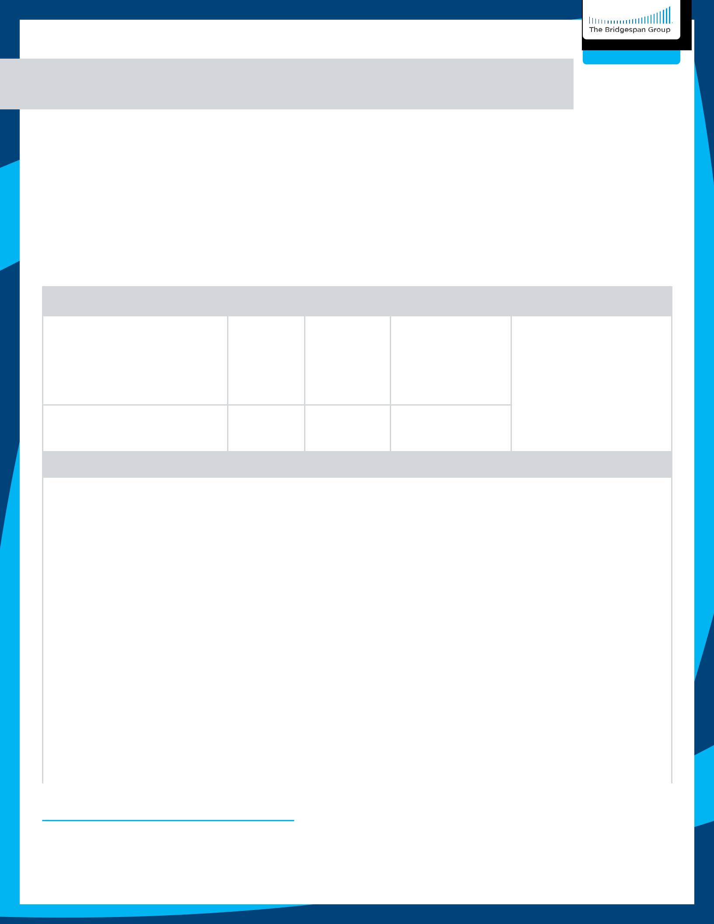
Effective

Meetings

Agenda Template: Client Example

Senior Leadership Team1 Meeting

August 19, 2025 - Monthly Meeting Agenda

Facilitator: Emmanuel

Timer: Louise

 | Topic/Item | Owner |  | Time | Role of Team | Prework
 | Topic/Item | Owner |  | (min) | Role of Team | Prework
 | Follow-Up Items
 | Credit Card Policy | James | - |  | Share and update
 |  |  |  |  |  | See written updates
 | Draft Accounts Payable Policy | James | - |  | Share and update | See written updates
 | Draft Accounts Payable Policy | James | - |  | Share and update | template2

RSM Annual Audit Fieldwork James

-

Share and update

New Items

2019 Employee Engagement | Maria + OD | 40 minutes | Share and update | None
Survey Results Overview | Team
SLT Shared Administrative | Maria | 10 minutes | Discussion | None
Assistant
Contract Management Policy | Anne | 10 minutes | Review and | Read policy and
Contract Management Policy | Anne | 10 minutes | discuss | authorization document
Strategic Plan Updates | Jennifer | 15 minutes | Discussion | Review new one-page
 |  |  |  | overview document
 |  |  | Discussion: timing
Virtual Town Hall Preparation | Louise | 10 minutes | & call for proposed | None
 |  |  | discussion topics
Next Steps/Action Items/ | Emmanuel | 5 minutes | Confirm the plan | None
Assignments

21

