Return
Unwanted
Medicines
RETURN UNWANTED MEDICINES
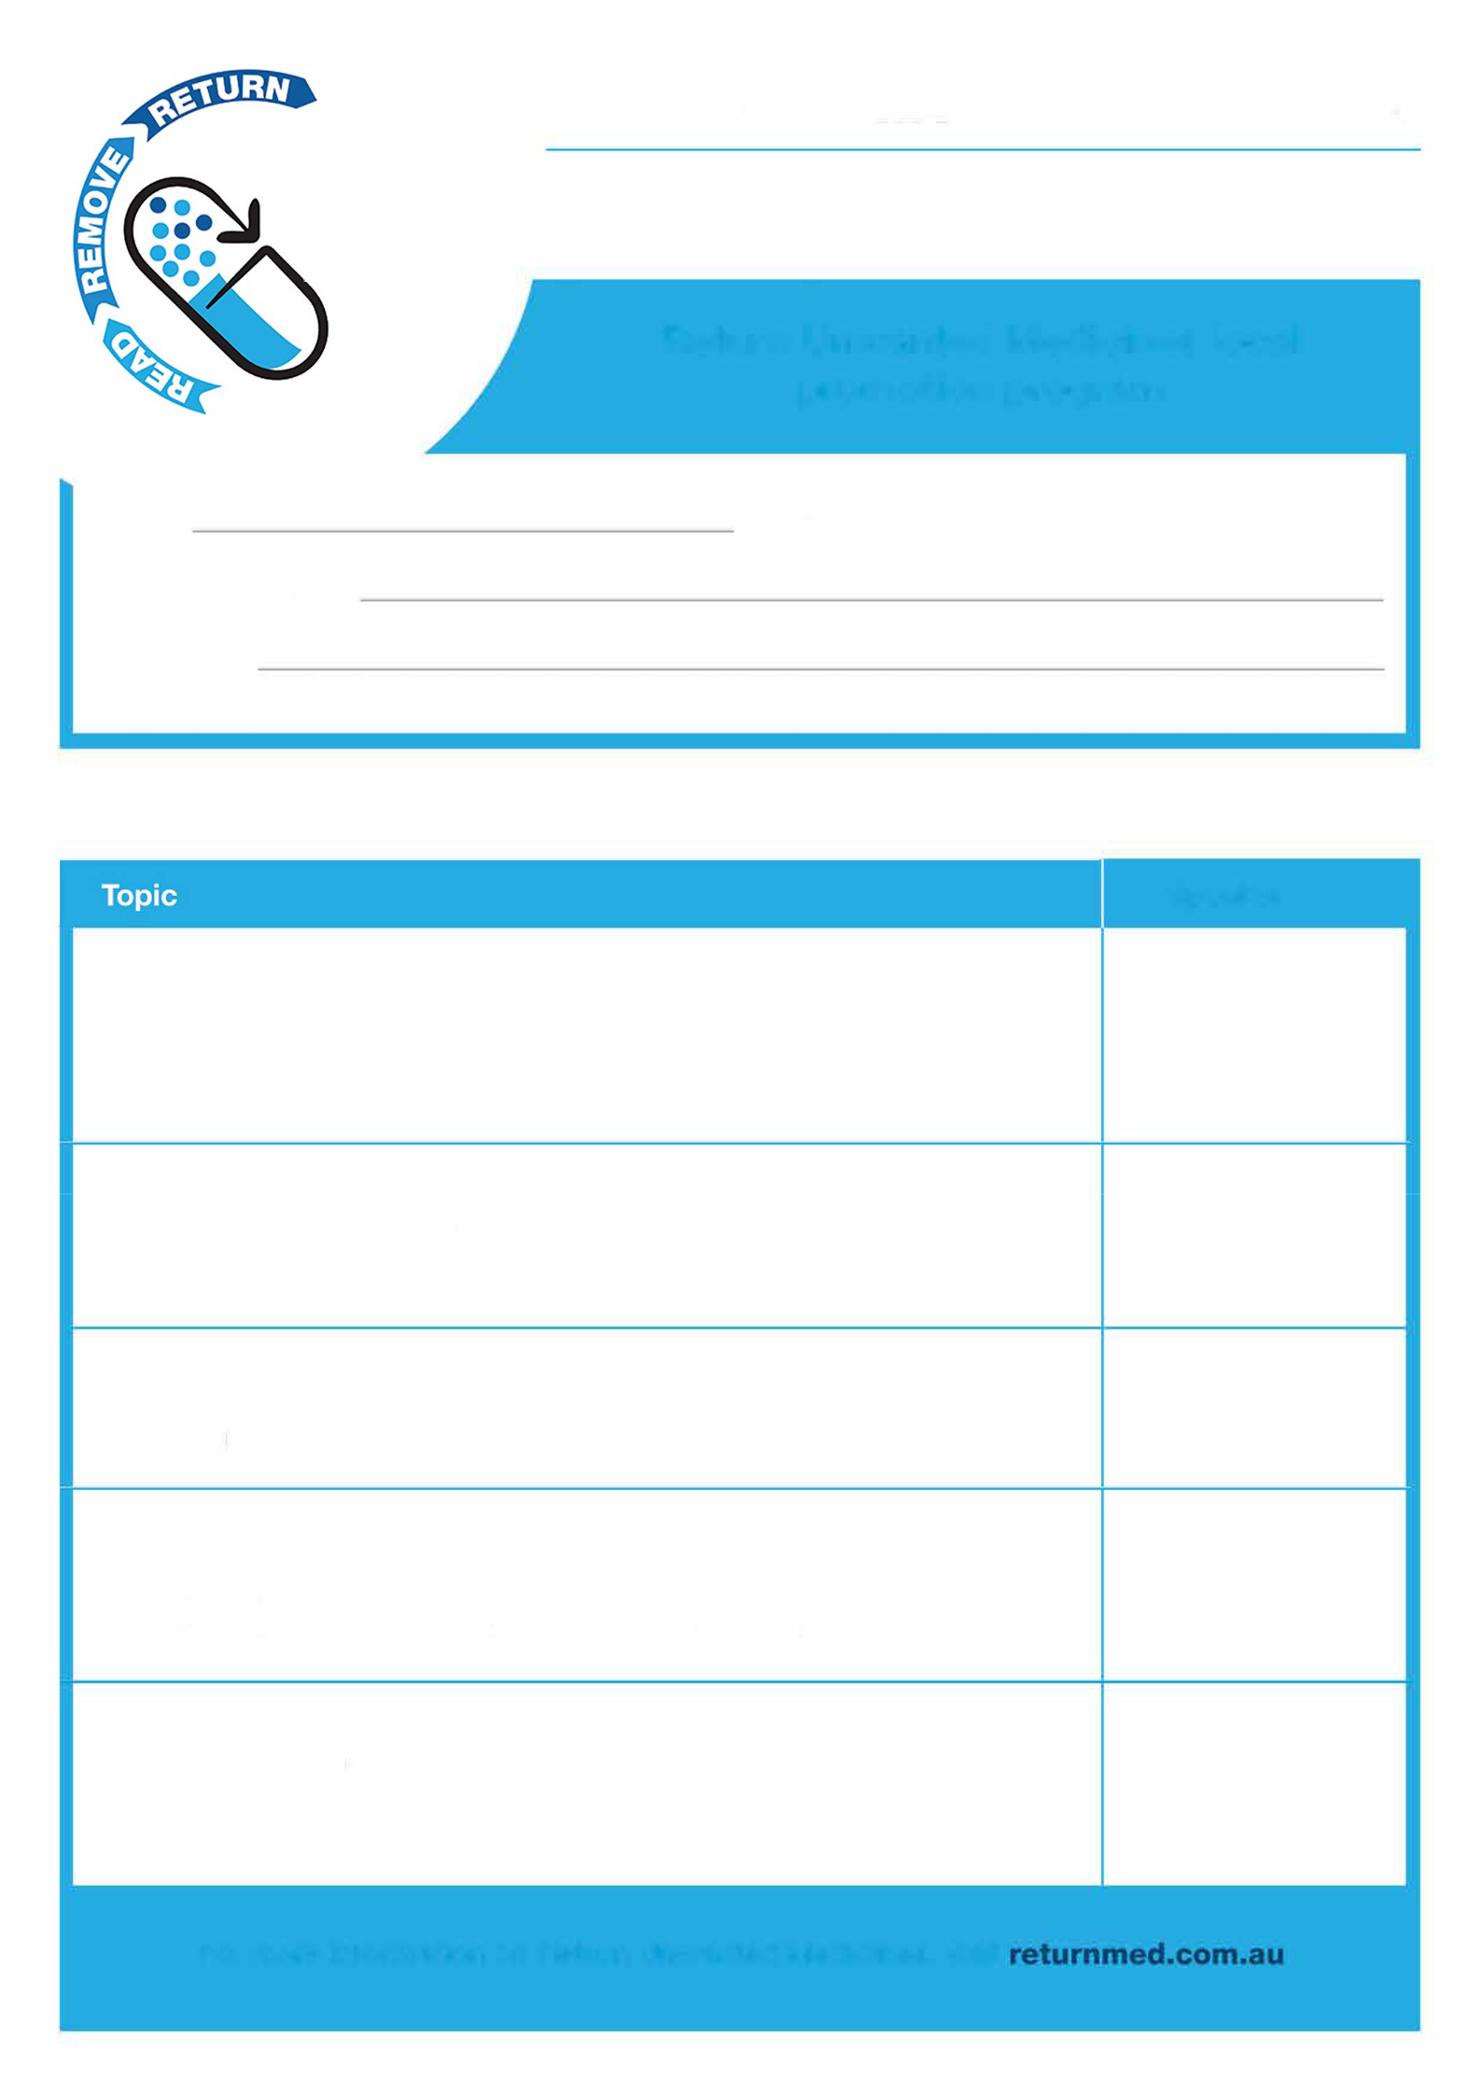

STAFF MEETING AGENDA

Return Unwanted Medicines local

Promotion program

Date: Time: _________________

Meeting facilitator:

Attendees:

AGENDA ITEMS

Speaker

- Background of Return Unwanted Medicines (or The RUM Project)
  - Aim of the program

  - Why it's important

  - How it works

  - FAQs

- What medicines RUM bins can safely collect and dispose of
  - Type of medicines customers can return

  - Separate process for sharps or S8 medicines

  - Where the RUM bins are transported to / incineration process

- New consumer campaign
  - Objective of new consumer campaign

  - Read, Remove, Return

  - The RUM Project Audit 2016 results

- Staff roles
  - How both pharmacists and pharmacy assistants can encourage customers to return unwanted medicines
  - Opportunities to engage customers about RUM in pharmacy

- Questions
  - For more information, visit returnmed.com.au

  - Downloadable resources are available for pharmacists at returnmed.com.au

