Retrospective Template

<Project Name> Sprint Summary

Sprint Ending <Date>

Context
First Day of Sprint:
Last Day of Sprint:
Working Days in Sprint:

Team Members
The following people participated in the sprint. Also listed are the days they were expected to work and the number of days they did work.
Name | Planned Days | Worked Days
<name> | 10 | 10
<sick person> | 10 | 8

Metrics
The following are key metrics being tracked by the team.
<Include in here any metrics important to the ScrumMaster, stakeholders or the team. Keep it simple. Some examples are shown but also consider things like the number of defects found or fixed, number of automated tests added, code coverage, number of builds deployed, or so on. If you are building the software for a client and need to report on cost, include things like billable hours and cost in this section.>
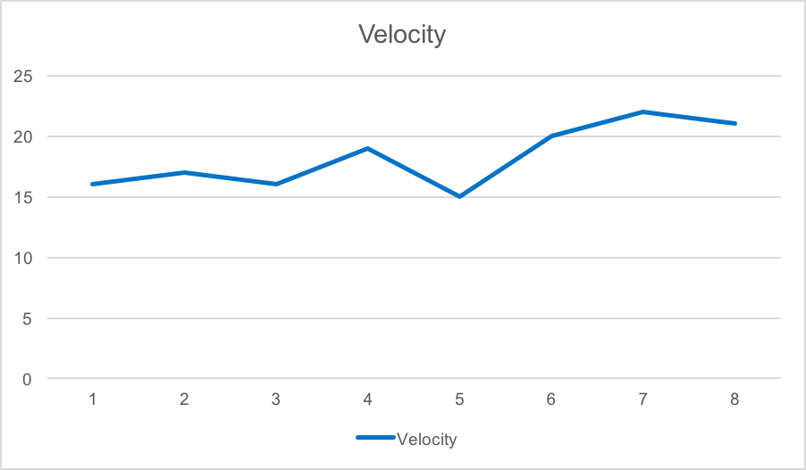

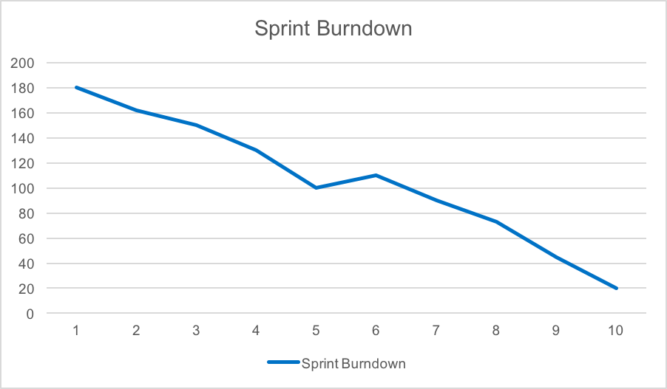

Contents and Assessment
Points Planned: 7
Points Earned: 5
Story | Points | Result
<story> | 2 | Finished
<story> | 1 | Finished
<story> | 2 | Not finished
<story> | 2 | Finished

Sprint Review
The sprint review was held on <date> and attended by <names>. Before approving or rejecting product backlog items as noted above, key decisions from the review were:
- <first decision>
- <second decision>

Sprint Retrospective
The team held a sprint retrospective on <date>. It was attended by <everyone or list>. Key decisions were:
- <first decision>
- <second decision>

