
Retrospective Template
Start / Stop / Continue

Utilize the Start, Stop, and Continue Team Retrospective Template to evaluate your last sprint, workshop, or project milestone. Ensure your stakeholders give and receive feedback, identify risks, and areas to improve.


START  STOP  CONTINUE

What are examples of things0 we need to start doing?


What must we avoid or stop0 doing; What hasn't worked?
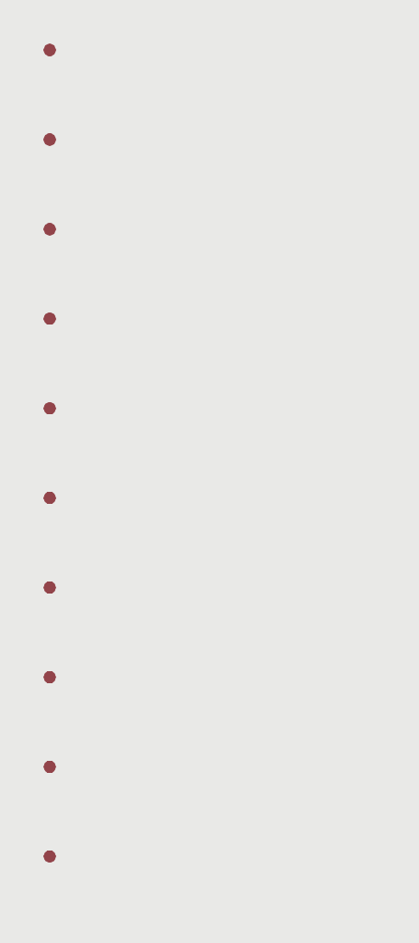

What are we doing well that0 we should continue doing?


© 2022 Design ACE. All rights reserved. |  | www.designace.ca
www.designace.ca | © 2022 Design ACE. All rights reserved. | www.designace.ca


Full Curated Workshops

 design
A C E

designACE is a single source for planning workshops that drive strategy discussions and inspire high-performing teams.

We help teams increase their productivity and improve their creative output by combining traditional problem-solving techniques with Design Thinking methods and frameworks.
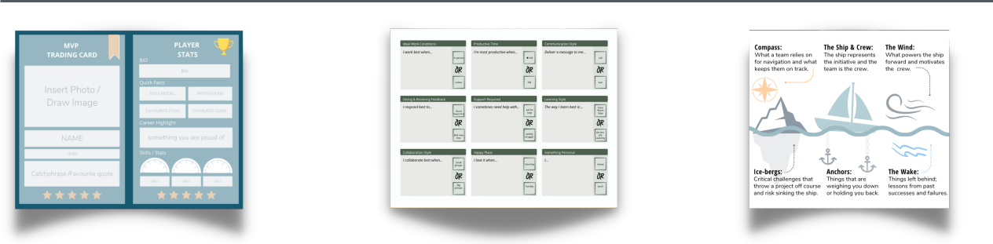

Trading Cards | User Manual | Strategic Review
By creating a personal | Share user manuals | Assess team dynamics,
trading card, you learn | to learn more about | and align on
about each other's | your teammates and | challenges you may
strengths, work styles, | how to work | face while reaching
and interests. | effectively with them. | your goals.
Team Booster | Team Building | Team Alignment
A fully facilitated session | A fully facilitated team- | A fully facilitated
to amplify engagement | building session to | interactive working
and set the stage for | focus on developing | session to align people,
creative problem- | empathy & forming | teams and projects
solving. | connections. | toward success.
[ 30 minutes ] | [ 60 minutes ] | [90 minutes]
Starting at | Starting at | Starting at
$250 | $650 | $1,000

