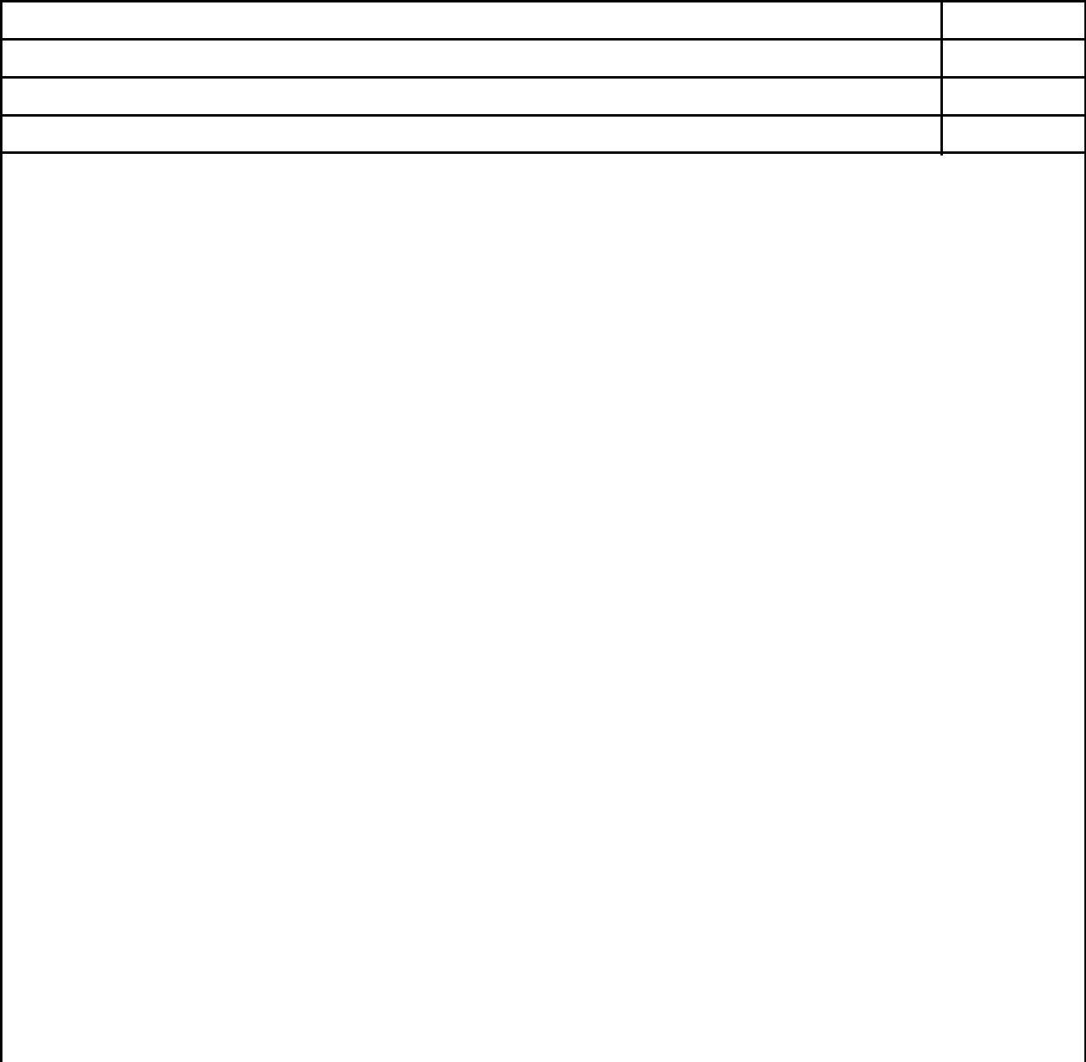
Company Name Here

Rent Ledger

*Use this ledger if you do not have an existing ledger
Tenant Name:

Address:
 |  | Rent Due |  | Rent Paid |  |  | Late Fees(per lease) |  |  |  | Total Due
Mar-25
Apr-25
May-25
Jun-25
Jul-25
Aug-25
Sep-25
Oct-25
Nov-25
Dec-25
Jan-26
Feb-26
Mar-26
Apr-26
May-26
Jun-26
Jul-26
Aug-26
Sep-26
Oct-26
Nov-26
Dec-26

I certify that the information presented in this certification is true and accurate to the best of my knowledge. The undersigned further understand(s) that providing false representations herein constitutes an act of fraud.

_____________________________________ Landlord Signature Date

_____________________________ Tenant Signature D

