Statement of Work Templates

Agreement made this ___ day of ______, 20__ by and between NYU, a New York education corporation
having its principal office at 70 Washington Square South, New York, NY 10012 (the "University") and
______________________,ª having its principal office at _______________________ ("Consultant").

- The Work

Consultant shall provide the services and deliverables (hereinafter "the Work") set forth in one or more Statements of Work signed by the parties and specifically referencing this Agreement (each a “Statement of Work” or “SOW”).

- Fees

For the satisfactory performance of the Work by the relevant dates set forth in the applicable SOW, the University shall pay Consultant in accordance with the schedule and rates.

- Term and Termination

Unless earlier terminated in accordance with section 3.B, this Agreement shall be effective as of the date set forth above and shall [terminate on ___________] extend until the Work has been performed in full to the satisfaction of the University].
- Consultant Status

- Confidentiality.

Consultant and its employees, agents, and representatives shall hold in confidence and shall not disclose, distribute, sell, copy, or otherwise disseminate or use (other than in the performance of the Work) the University’s “Confidential Information,” which includes (i)
- Intellectual Property

The Work shall be deemed to be work made for hire and the University shall own all right, title, and interest in and to the Work and each part and component thereof, whether or not patentable or copyrightable.
- Insurance

Consultant will procure and maintain at its expense while performing the Work Commercial General Liability Insurance with a combined bodily injury.
- Indemnity

Consultant shall defend, indemnify and hold harmless the University from and against any and all losses, claims, allegations, demands, suits, proceedings, investigations, prosecutions,etc.
- Use of University's Name

Consultant shall not use the name, trade name, trademark, or any other designation of the University, any school, college, division, department, or other unit of the University.

- Notices

All notices or communications pertaining to this Agreement shall be given in writing either by personal delivery, by overnight courier or by registered U.S. mail with return receipt.

- Governing Law

This Agreement shall be governed by and construed in accordance with the laws of New York, without regard to principles relating to conflicts of law.

- Assignment

Neither party hereto may assign its rights or obligations under this Agreement without the prior written consent of the other.

- Amendment

Neither this Agreement nor any term, provision, or condition hereof may be changed, supplemented, waived, or discharged orally, but only by an instrument in writing signed by both parties. .

- Miscellaneous

This Agreement constitutes the entire agreement of the parties regarding its subject matter, and it supercedes any and all prior and collateral negotiations,

- Non-Exclusivity

The University reserves the right to enter into or maintain contracts with other firms that provide similar services/products.

IN WITNESS WHEREOF, each party has executed this Agreement.

NEW YORK UNIVERSITY | CONSULTANT
By: | By:

Name: Name:

Title: Title:

Date: Date:

- Engagement Details

Project Name:

SOW/Quote # and Date:

Scheduled Start Date:

Scheduled End Date:

Business Manager(s):

NYU Project Manager:

- Project Description & Scope of Work

- Timeline & Deliverables (add line item as needed)

Project Phase | Milestone or Deliverable | Estimated Completion Date

4. Fees (add additional Resources, if needed)
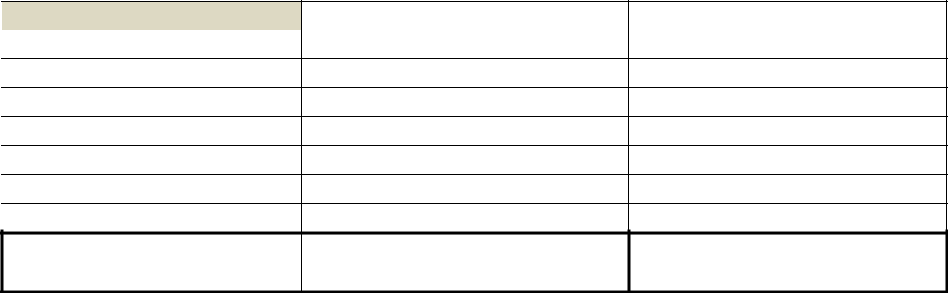

Resource 1 |  | Resource 2

Resource Name:

Email and Phone No.:

Role:

Hourly Rate:

Number of Hours:

Sub-Total (Rate X Hours):

Travel/Other Expenses:

Total Cost of Engagement*:

