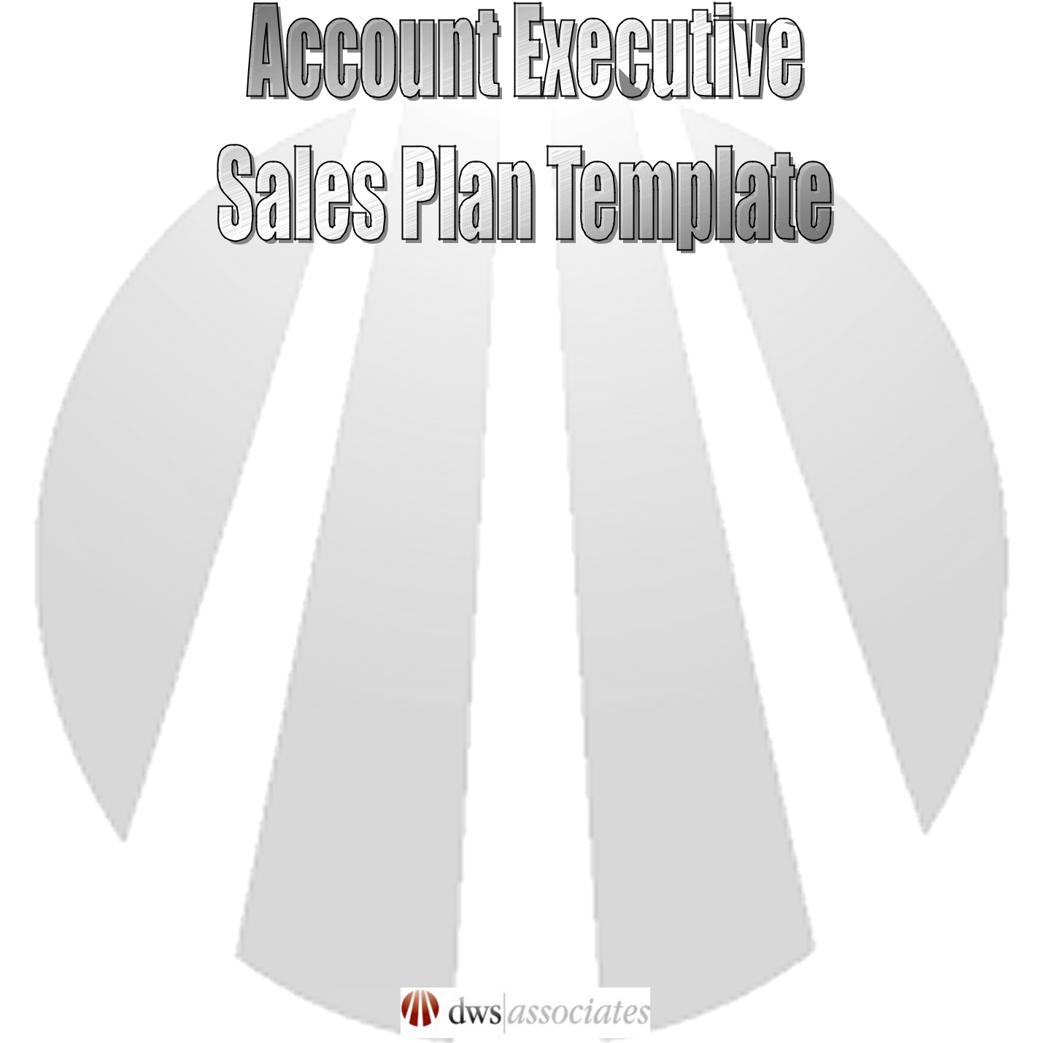

Instructions:

Use this template to develop your account executive’s sales account plans for each of your prospect or client (customer) accounts for each of your sales associates in your sales organization. This plan is a way of organizing and managing you client account plans so that you can optimize the services and products that are offered to them. This is a detailed sales plan that the sales executive should follow in conducting business with the client. It will help you and other members of your marketing and sales teams understand their business model and identify their needs and how your organization can better fill them than your competitors. Fill in all information required in the blue text sections. You may delete sections and rows that do not apply to your business model.
 | Account Executive Sales Plan
ACCOUNT EXECUTIVE: | Enter account manager name.
PHONE: | Enter phone number.
EMAIL: | Enter email address.
SUPPORTING | Enter any support team members assigned to this sales representative. i.e. Inside
ACCOUNT TEAM: | Sales, Sales Engineer, Product Marketing, and/or Executive Sponsors, etc.
PLAN PERIOD: | Enter plan year (period).
PLAN DATE: | Enter date of plan creation.
PLAN UPDATED: | Enter date plan was modified.
PLAN VERSION #: | Enter plan version #.


TERRITORY:

Enter sales representative’s territory including details such parameters and size. If a territory is geographical in nature, consider adding a small map graphic as well. Be sure to document any EXCLUSIONS or EXCEPTIONS in this section as well.)

QUOTA:

Enter sales representative’s quota. Describe the percentage this quota makes up of overall company quota.

TRAINING REQUIRED:

After completing the rest of the sales plan, identify and document key training necessary for this sales representative to help them achieve success. i.e. process training, prospecting training, writing effective proposals, etc.. Enter training methods, programs and vehicles.

OVERALL GOALS

OVERALL PROSPECTING GOALS:

Enter three goals for your territory account plan. These goals must to be measurable. (i.e., generate 5 new qualified leads per week. Make 100 suspect contacts a month and identify 10 new qualified sales leads for the same period. Issue two sales proposals a month to new customers.)

OVERALL TARGET ACCOUNT GOALS:

Enter three goals. These goals must be measurable. Submit five proposals to target accounts per quarter. months.)

(i.e., identify three new target accounts per quarter. Close two new deals with target accounts every six

OVERALL KEY ACCOUNT GOALS:

Account Executive Sales Plan Page 1

Account Executive Sales Plan

Enter three goals. These goals must be measurable. (i.e., Grow existing key account solution revenue by 10%. Sell new solution offering into two keys accounts every six months. Increase customer satisfaction rating by 25%.)


PROSPECTING STRATEGY

TARGET SOURCES FOR PROSPECTING:

Enter names and descriptions of prospecting sources that you will use to develop your prospecting list. Sources include compiled and buyer mailing list, publication subscription lists, conference and trade show attendees, consumer and industrial association lists.

PROSPECTING SCHEDULE:

Enter your prospecting schedule details.

PROSPECTING APPROACH:

Enter your prospecting approach. How much time will you devote to prospecting? How many “call” will you make? What types of prospects will you approach? How will you make the initial contact and follow up contacts? What kind of research will you do on prospects before contacting them? What will be your selling proposition? Etc. Your prospecting approach should be based on what you define as a qualified lead.

PROSPECTING TOOLS NEEDED:

Enter list of prospecting tools needed to achieve sales goals. Letters? Telemarketing scripts? White papers? Free gifts? Marketing collateral? Sales aids? Etc.

REPORTING SCHEDULE: (Set reporting periods, then determine what will be reported for that period: # of calls made; # of contacts made; # of qualified leads identified; # of qualified opportunities; # of requests for more information; # of requests for meetings; # of demo requests; # of presentations; # of proposals submitted; # new bids: # of closed sales; etc.)

 | Period | What’s Reported for Period
 | Daily | Specify
 | Weekly | Specify
 | Monthly | Specify
 | Quarterly | Specify
 | Semi Annually | Specify
 | Yearly | Specify
 | Account Executive Sales Plan | Page 2

Account Executive Sales Plan


Account Executive Sales Plan Page 3
Account Executive Sales Plan


ACCOUNTS PLANS

TARGET ACCOUNTS:

 |  | Target Account 1 | Target Account 2 |  | Target Account 3
 | Name | Enter organization name.
 |  | Target accounts are those that you
 |  | don’t do business with, but already
 |  | know there is a need for your
 |  | solution (product/service) offering
 |  | and/or they are using a
 |  | competitive solution.
 | Top Contacts/Role | Enter primary contacts, including
 |  | title, role in the sales/purchase
 |  | process, and contact information.
 | Industry Sector | Enter industry sector that the
 |  | business is in.
 | New Solution (Product/Service) | Solution (Product/Service) Offering
 | Offering Proposed | (include product, services,
 |  | financing, fulfillment, etc. in
 |  | solution description)
 | Goals | Enter the goals for this account.
 | Potential Opportunity in $’s | Enter the potential sales
 |  | opportunity for this account if they
 |  | were to purchase all of the
 |  | solutions that we can offer their
 |  | business.
 | Advantages | Enter known advantages over
 |  | competition in this account,
 |  | including potential opportunities.
 | Obstacles | Enter list of known obstacles,
 | Account Executive Sales Plan |  |  | Page 4

Account Executive Sales Plan


Action Plan

including the areas where you
believe there will be obstacles to

your success in penetrating this
account.

Enter your action plans for this
action.

Account Executive Sales Plan Page 5

Account Executive Sales Plan

KEY ACCOUNTS:

 |  | Key Account 1 | Key Account 2 |  | Key Account 3
 | Name | Enter organization name.
 |  | Key accounts are those that offer
 |  | you the best opportunity for
 |  | growing your territory’s business.
 |  | They are not necessarily your
 |  | largest accounts.
 | Top Contacts/Role | Enter primary contacts, including
 |  | title, role in the sales/purchase
 |  | process, and contact information.
 | Industry Sector | Enter industry sector that the
 |  | business is in.
 | Current Solution | Solution (Product/Service) Offering
 | (Product/Service) Offering | (include product, services,
 | Purchased | financing, fulfillment, etc. in
 |  | solution description)
 | New Solution (Product/Service) | Solution (Product/Service) Offering
 | Offering Proposed | (include product, services,
 |  | financing, fulfillment, etc. in
 |  | solution description)
 | Sales History | Enter past sales history by month,
 |  | quarter, or year depending on the
 |  | period covered by the plan.
 | Sales Forecast | Enter the future sales forecast for
 |  | the period (month, quarter, or
 |  | year.)
 | Potential Opportunity in $’s | Enter the potential sales
 | Account Executive Sales Plan |  |  | Page 6

 | Account Executive Sales Plan
 | opportunity for this account if they
 | were to purchase all of the
 | solutions that we can offer their
 | business.
Advantages | Enter known advantages over
 | competition in this account,
 | including potential opportunities.
Obstacles | Enter list of known obstacles,
 | including the areas where you
 | believe there will be obstacles to
 | your success in penetrating this
 | account.
Action Plan | Enter your action plans for this
 | action.


Account Executive Sales Plan Page 7
Account Executive Sales Plan


PROSPECTING & ACCOUNT MANAGEMENT ACTIVITIES:

JAN | FEB | MAR | APR | MAY | JUN
Enter a schedule of your | Enter a schedule of your | Enter a schedule of your | Enter a schedule of your | Enter a schedule of your | Enter a schedule of your
prospecting and account | prospecting and account | prospecting and account | prospecting and account | prospecting and account | prospecting and account
management activities for | management activities for | management activities for | management activities for | management activities for | management activities for
the month. Your plan | the month. Your plan | the month. Your plan | the month. Your plan | the month. Your plan | the month. Your plan
needs to be specific and | needs to be specific and | needs to be specific and | needs to be specific and | needs to be specific and | needs to be specific and
measurable, and should be | measurable, and should be | measurable, and should be | measurable, and should be | measurable, and should be | measurable, and should be
reviewed every month. | reviewed every month. | reviewed every month. | reviewed every month. | reviewed every month. | reviewed every month.

 | JUL | AUG | SEP | OCT | NOV | DEC
 | Enter a schedule of your | Enter a schedule of your | Enter a schedule of your | Enter a schedule of your | Enter a schedule of your | Enter a schedule of your
 | prospecting and account | prospecting and account | prospecting and account | prospecting and account | prospecting and account | prospecting and account
 | management activities for | management activities for | management activities for | management activities for | management activities for | management activities for
 | the month. Your plan | the month. Your plan | the month. Your plan | the month. Your plan | the month. Your plan | the month. Your plan
 | needs to be specific and | needs to be specific and | needs to be specific and | needs to be specific and | needs to be specific and | needs to be specific and
 | measurable, and should be | measurable, and should be | measurable, and should be | measurable, and should be | measurable, and should be | measurable, and should be
 | reviewed every month. | reviewed every month. | reviewed every month. | reviewed every month. | reviewed every month. | reviewed every month.
 | Account Executive Sales Plan |  |  |  | Page 8

Account Executive Sales Plan
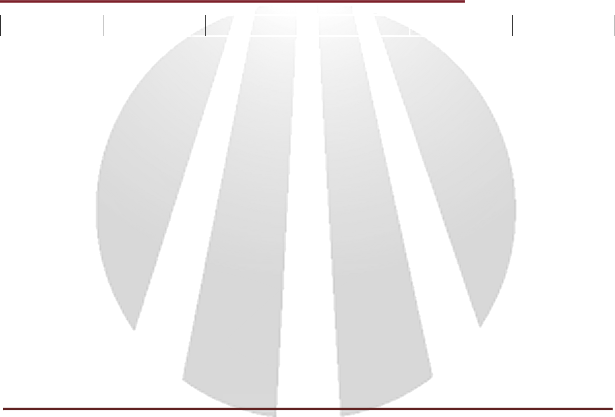

Account Executive Sales Plan Page 9

