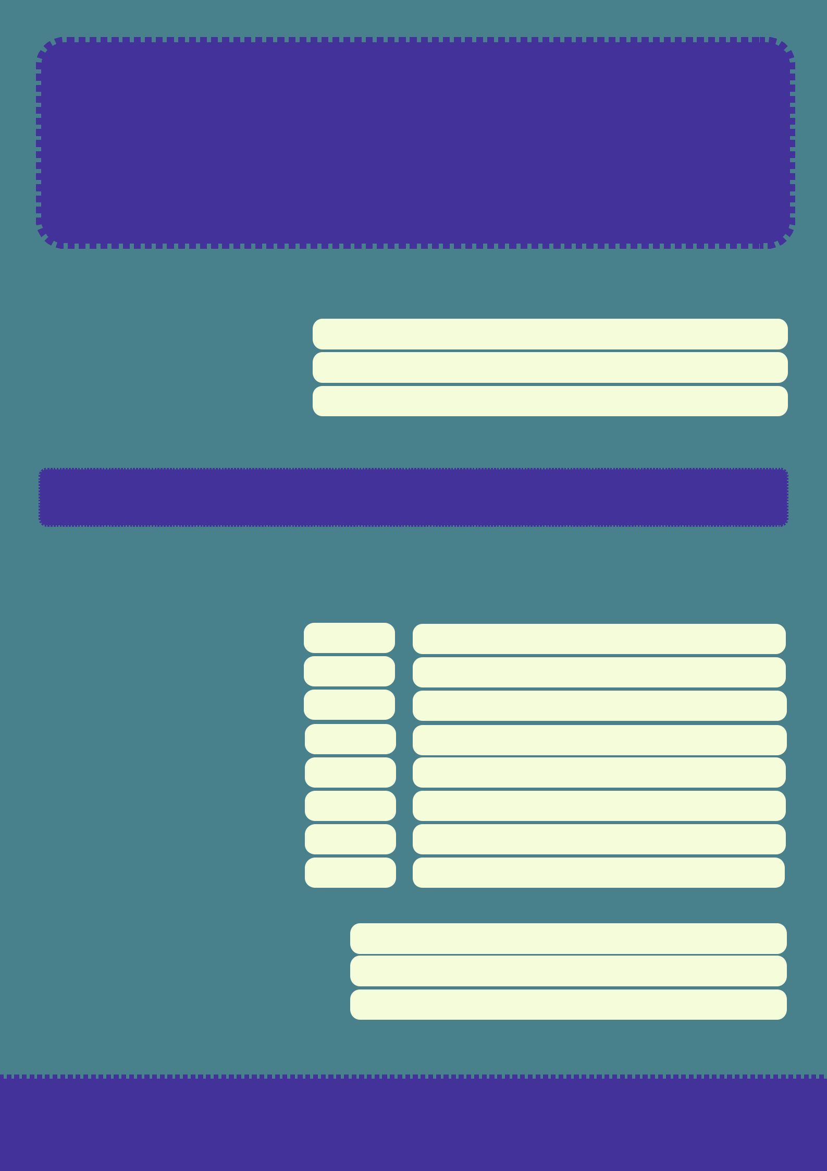
REPORT CARD

DBT PLEASE SKILL

NAME:

AGE:

DATE

CHOICES AND ROUTINES:

SUBJECT GRADE COMMENTS

GETS PHYSICAL ACTIVITY

EATS HEALTHY

EXERCISES REGULARLY

GETS ENOUGH SLEEP

TAKES MEDS

DOES NOT ABUSE D + A

MAKES TIME FOR FUN

REGULAR SELF-CARE

HABITS AND ATTITUDES:

ADDRESS

