Time & Material service Contract
TIME & MATERIALS SERVICE LEVEL AGREEMENT (SLA) & SUPPLEMENTARY

TERMS & CONDITIONS

1. Definition

Insource will provide Technical Services and Technical and Business Consultancy Services to the Client.

- Definition of Terms

“Service”, “Services” “Time & Materials”, is the provision of time-based technical and consultancy services.

- Methods of Delivery

The Services discussed can be provided by one or more of the following methods:

- On-Client site

- Off-Client site
- Remote connection

- This SLA Period

This SLA Period is for the duration of the Project, or 12 months, whichever is the shortest. The Client must make suitable provision for the Services to be called and commenced within 3 months of Insource receiving the signed Insource Proposal Agreement (IPA) and/or other agreed method of order summary.

- Consultancy or other work carried out on a time and materials basis

Services are provided on a time and materials basis for Projects in which it is not possible to accurately estimate their size or scope or when it is expected that the Project requirements are likely to change. Therefore, Insource agrees to undertake and the Client agrees to accept “time and materials” Services on the following basis:

Any estimate of time needed to complete a task will be given in good faith, however it will not be a commitment to complete the work or achieve a given deliverable within an estimated time; Insource will, if requested, complete the work subject to the Client accepting additional charges for additional time required.

Any advice given will be given in good faith, however, the Client will be responsible for satisfying itself that the suggestion will produce the result it requires and any decision to act on advice given will be the responsibility of the Client and subject to the Client’s approval to proceed.

Insource will use an appropriate level of care and skill in carrying out the work under the Client’s direction and instruction, however, Insource cannot guaranty a satisfactory outcome.

- Service Levels

Service Level Grade | Service Level Description
A | Project Director/ Chief Technical and Business Process Architect
B | Senior Technical Architect/Senior Business Analyst
C | Senior Systems Developer/Technical Architect/Analyst
D | System Implementation Engineer/Product Trainer/Project Manager/Systems Developer
E | Implementation Engineer / Installation Engineer
F | Project Administrator
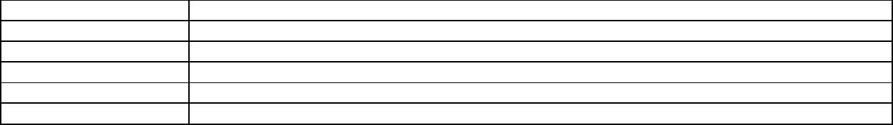

7. Working Times

Times are calculated on a standard working day and a standard working week. A working day will consist of no more than 7.5 hours, within the times of 8:00am to 6:30pm, UK time; a working week is Monday to Friday inclusive, excluding all UK Bank Holidays (Normal Working Hours). Should time incurred exceed 7.5 hours in any day then it will be accounted for on a pro-rata basis for that day. Should work be required to be carried out outside of these times in order to accommodate the Client’s requirements that are as a result of anything beyond Insources control then Insource will levy the following charges for the work:

Period | Day Rate Multiplier
Outside of a Normal Working Hours (Monday to Friday) | 1.5
Saturdays | 1.5
Sundays | 2.0
Bank Holidays | 2.0
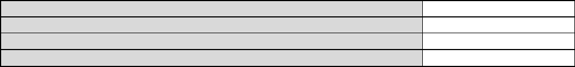

- Scheduling of Service Time

Every effort will be made to meet the needs of the Client and their timescales and, as such, we try to accommodate even the shortest notice requests. However, the less notice provided by the Client, the more difficult it is for Insource to accommodate. Additionally, short notice scheduling requires extensive project scheduling and rescheduling, therefore rate multipliers are applied against the standard day rates for the various notice periods as defined in the table below. Insource cannot guarantee to meet requested response times.

 |  | Multiplier applied to day
Type of Service | Advanced Booking Time | rate | Minimum Time Allocation
Standard | >5 days | 1.0 | 1 day
Reactive | 2-5 days | 1.25 | 1 day
Rapid | <2 days | 1.5 | 1 day

- Cancellation fees

Should the Client wish to cancel a scheduled Service, cancellation charges will apply as follows:

Notice Period | Cancellation fee
(prior to commencement date) | (as a % of multiplied day rate)
Greater than 5 days | 0%
Between 2 and 5 days | 50%
Between 1 and 2 days | 75%
Less than1 day | 100%
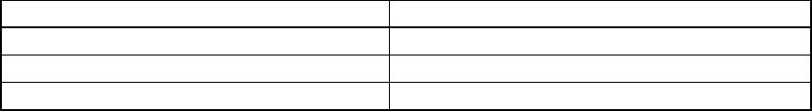

10. Ancillary Time Incurred in the provision of Services

Additional time will be charged for, should extraordinary time be incurred by Insource in the provisioning and scheduling of Services or should time be incurred that is not directly associated with the provision of the Services, which may be as a result of, but is not limited to, reasons such as:

Full, uninterrupted access to the system is not made for the full duration of the site visit or dial-in period. Missed milestones by the Client.

Information, personnel and resources from the Client are not made available when required at the agreed times, resulting in lost/wasted time by Insource personnel.

Failure by the Client (or any Client third party organisation) to complete any related element of its responsibilities. Delayed start date.

Difficulty in making contact with the Client, and persistent non-returning of calls and messages. Unscheduled or extraordinary meetings or discussion with the Client relating to the Project.
Lack of clear definition by the Client as to the tasks required.

These charges will be deducted from the balance of Service Time or, should there be insufficient funds, charged for separately.

  - Contacts

Requests for Services may only be made by the Client’s contacts agreed at the commencement to this SLA, or as notified in writing during the period of this SLA.

  - Reporting & Monitoring

Insource will provide statements detailing the Service Time balance at agreed intervals.

- Unused Services

Should it be anticipated there will be a balance of Service Time at the end of this SLA, the balance can be used as a credit against the purchase of other Products and Services from the Insource Product portfolio, provided that a request
Page 2 of 3

