

# Acknowledgments

## Formal Wording:

### Acknowledgment where document signer is personally known by the Notary:

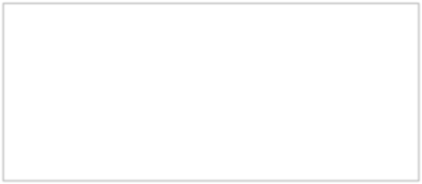

State of Arizona

County of

On this day of , 20 , before me personally appeared

(Name of signer), whom I know personally, and acknowledged that he/she executed the same.

(Seal)

Notary Public

**Informal Wording:**

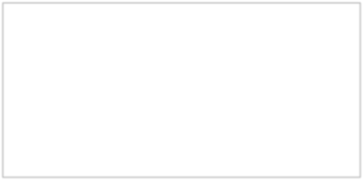

State of Arizona

County of

On (date) ,

(name of signer), personally appeared before me, whom I know personally to be the person who signed the above/attached document and he/she proved he/she signed it.

(seal)

Notary Public

Acknowledgment where the document signer’s identity is proven by a credible person whom the notary knows personally or whose identity was proved to the notary on the basis of satisfactory evidence of identity:

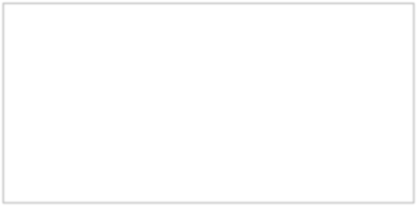

State of Arizona

County of

On this day of , 20 , before me personally appeared

(name of signer), whose identity was proved to me on the oath of (Name of credible person), a credible person by me duly sworn, and acknowledged that the signer signed the above/ attached document.

(seal)

Notary Public

Acknowledgment where the document signer’s identity is proven by satisfactory evidence:

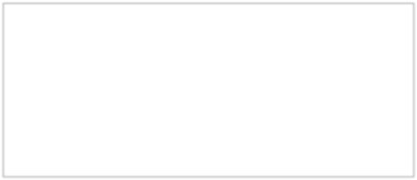

State of Arizona

County of

On this day of , 20 , before me personally appeared

(name of signer), whose identity was proved to me on the basis of satisfactory evidence to be the person whose name is subscribed to this document, and who acknowledged that he/she signed the above/attached document.

(seal)

Notary Public