Zero Based Budget Template

Income for January
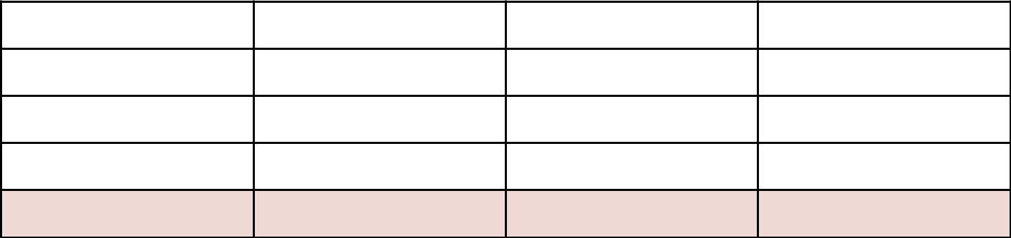

Estimated | Actual | Difference

Income 1

Side Hustle 1

Side Hustle 2

Total

Expenses
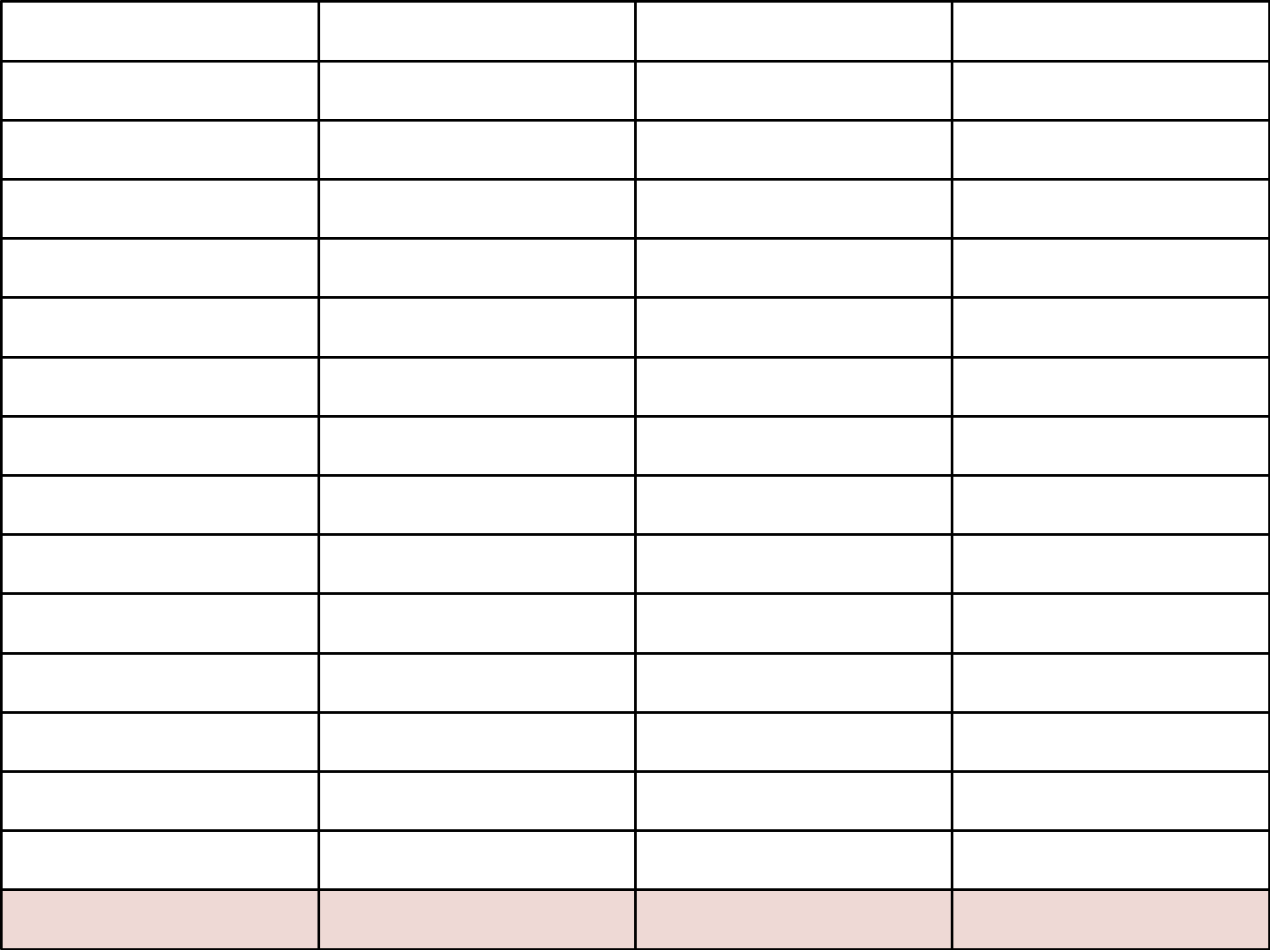

Category | Estimated | Actual | Difference

Savings/Emergency

Medical

Rent

Utilities

Groceries

Insurance

Transportation

Cell Phone Bill

Subscriptions

Loan Repayment

Pet Expenses

Shopping

Dining Out

Recreation

Total

