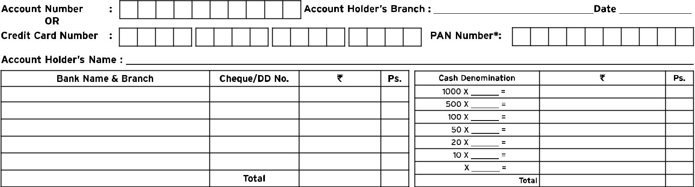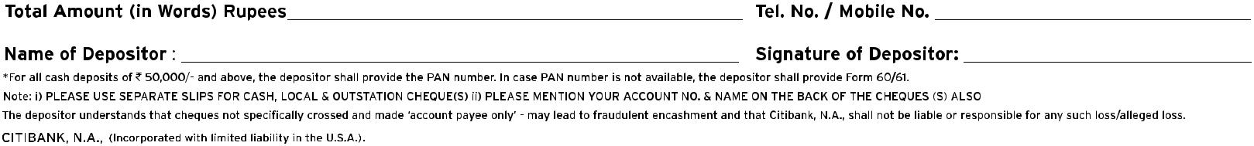Bank DEPOSIT SLIP TEMPLATE