LAB REPORT TEMPLATE

- Objective

What did you do? Why did you do it?

- Equipment
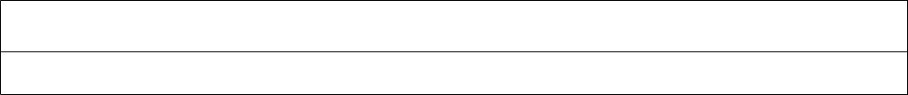

Hardware

Software

- Procedure

How did you do it?

Don’t copy the lab assignment’s procedure. Instead, give a summary of the steps you took to design and implement what you created in lab. If you did anything not mentioned in the assignment, or did anything differently, mention that.

- Results

What happened? Did it work as expected? If not, why? If it did work, how could you make it better?

- Discussion Questions

  - What is the .... ? (Include the question along with your answer.) The ... is a ...

- Conclusion

What was the point of this lab? (What questions were asked in the objective? )

- Attachments

  - List attachments including circuit schematics, VHDL code, etc.

  - Include the lab participation sheet as the last page of attachment
LAB REPORT TEMPLATE
Digital Logic Lab Participation

Lab Number:

Date of Lab:

Lab Participation

Provide the percent participation in lab by each lab partner:

Lab Member Name | Percent Participation

Checked by lab instructor:

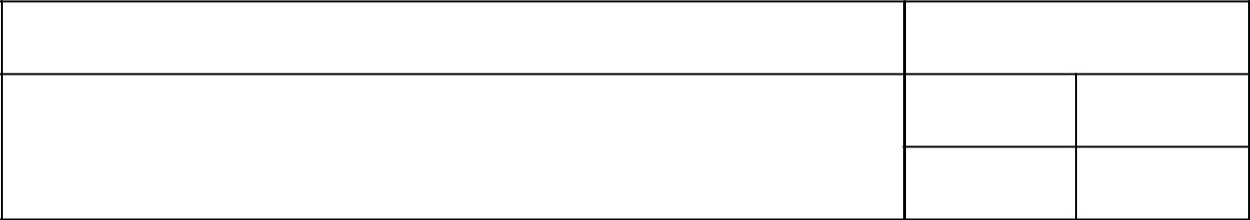
Name of Instructor | Circuit Works

Yes

No1

Lab Report Preparation

Provide the percent participation in lab report preparation by each lab partner:

Lab Member Name | Percent Participation

lab report.

